**Assignment Day 6 Solutions**

**Question 1:** **Create payload for windows .**

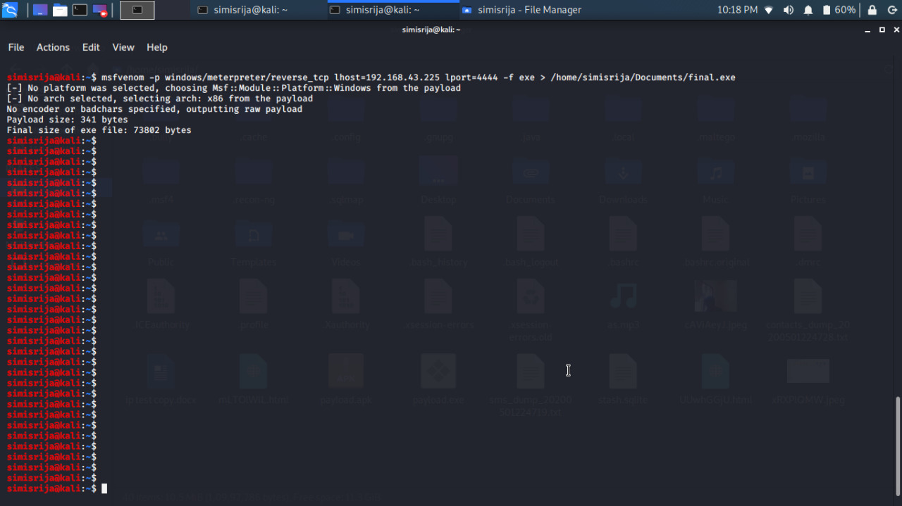

**Transfer the payload to the victim's machine.**

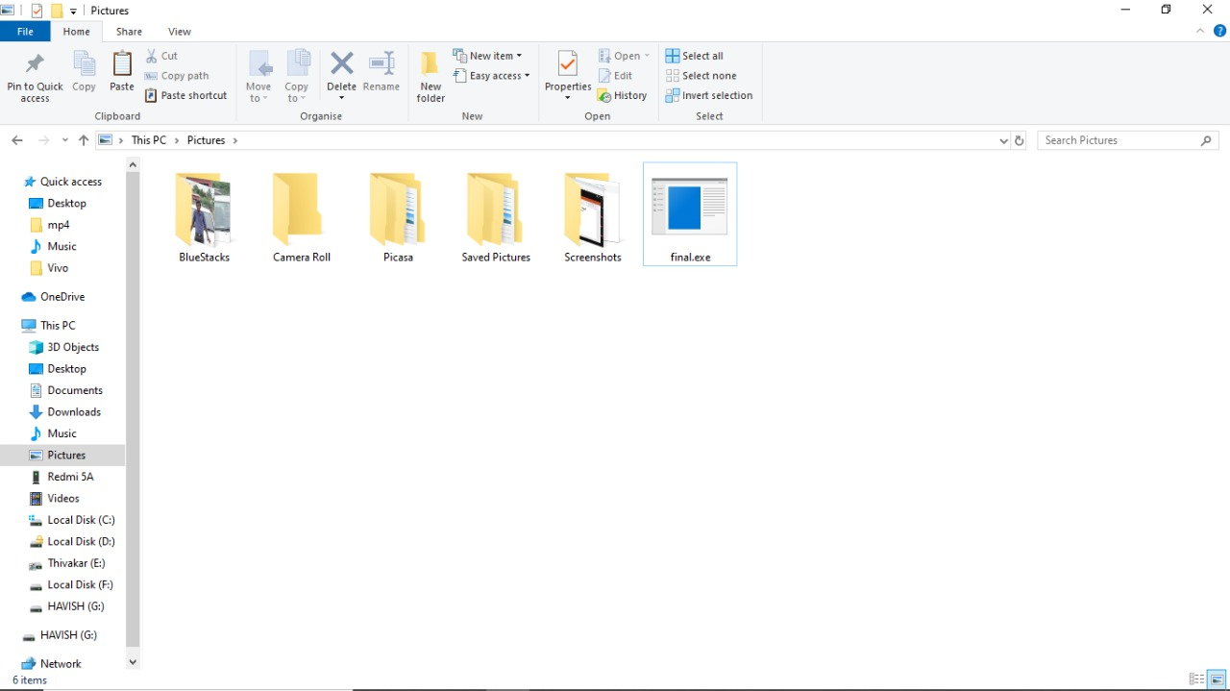

**Exploit the victim's machine.**

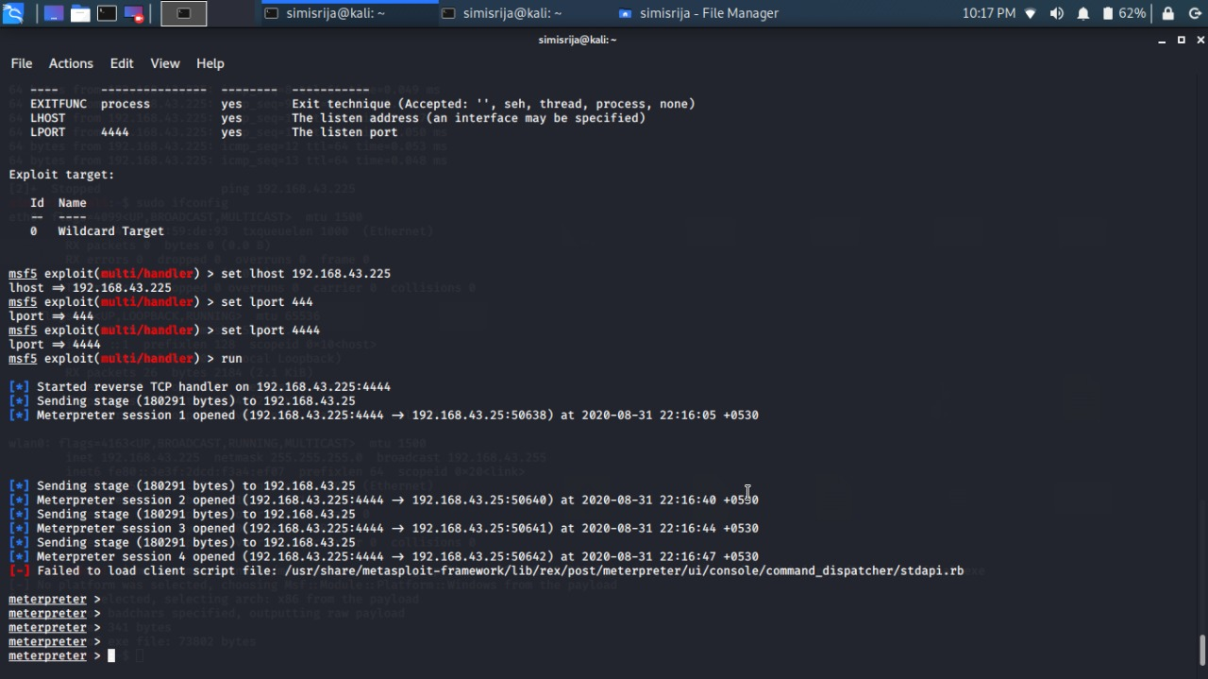

**Question 2:** **Create an FTP server**

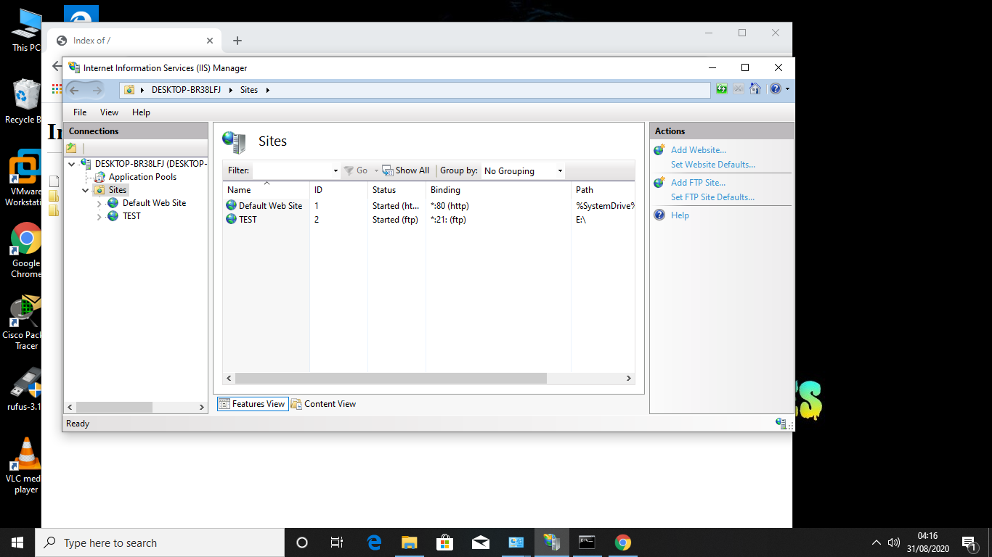

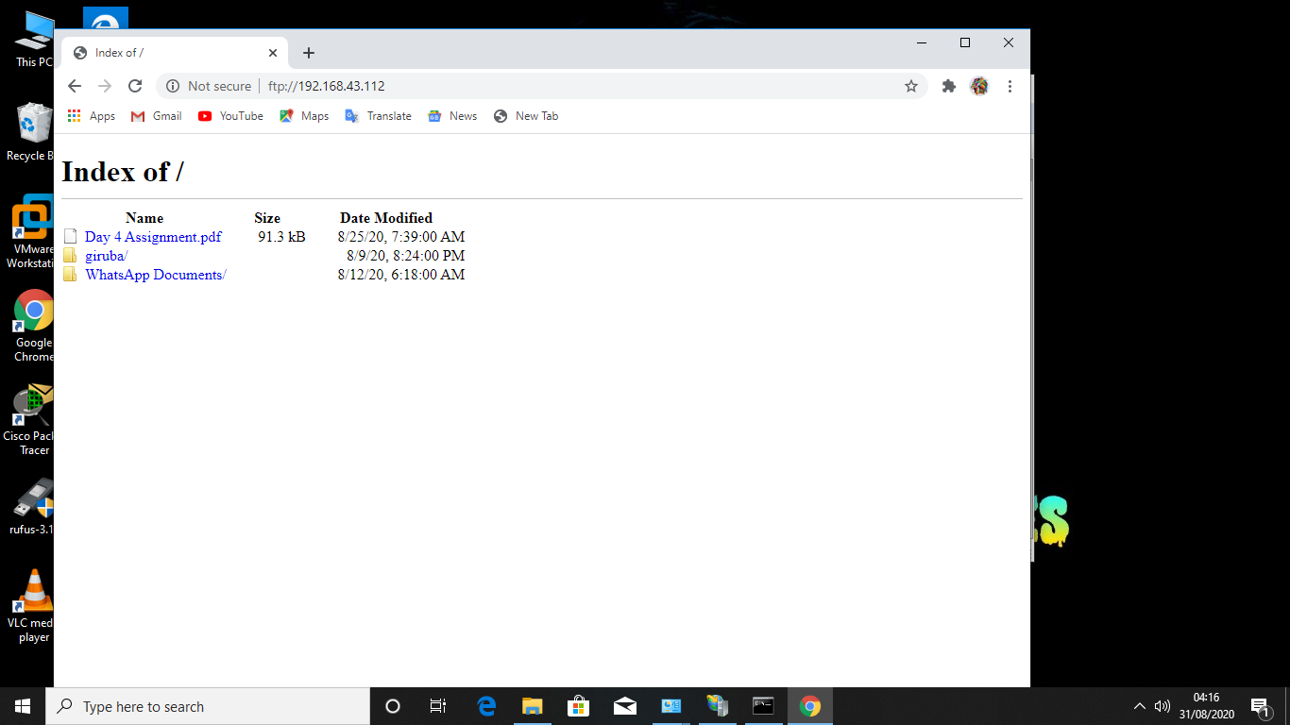

**Access FTP server from windows command prompt**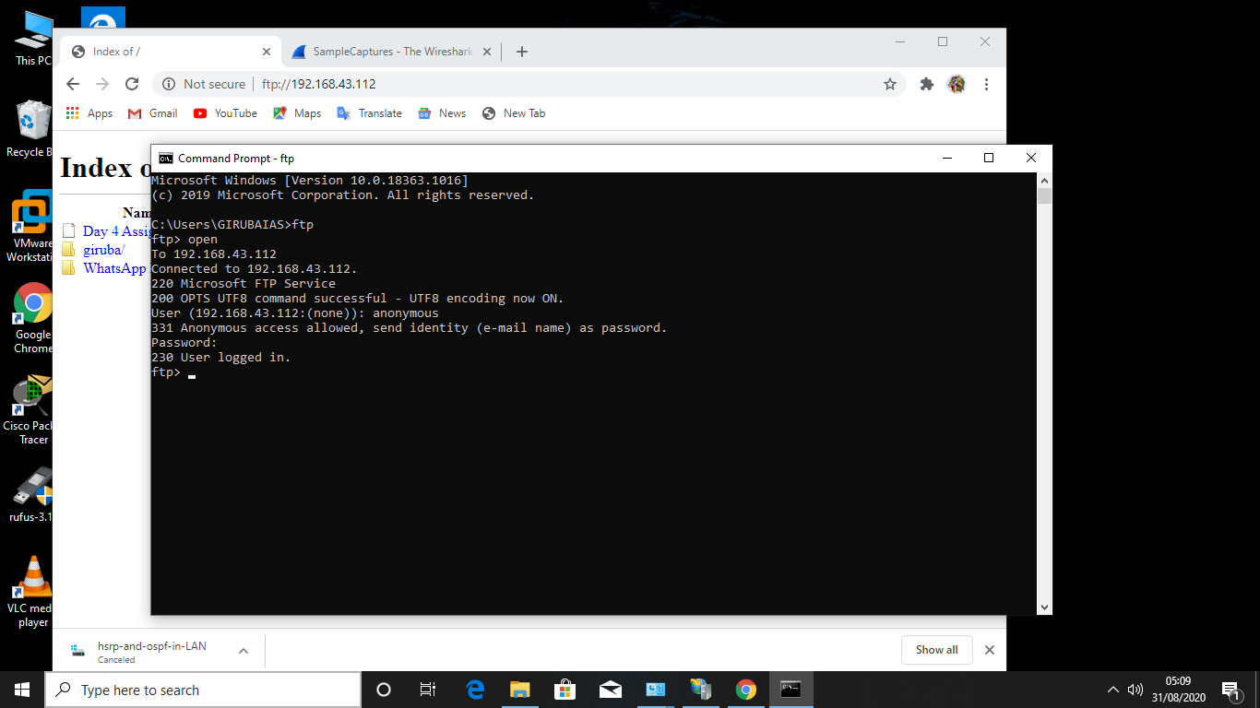

**Do an mitm and username and password of FTP transaction using wireshark and dsniff.**

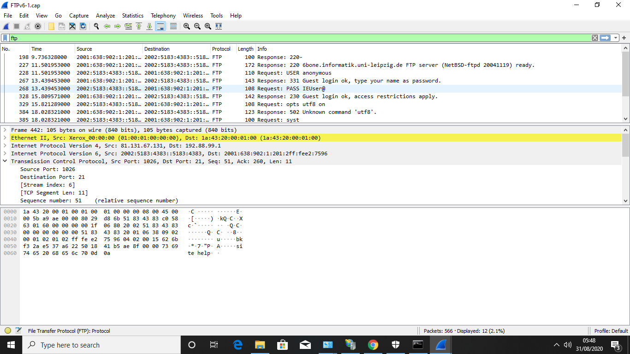

**User: anonymous**

**Login password:guest login giruba(my name)**

**DSNIFFING:**

